Air/Fuel Ratio Gauge Display – CGEA1.3

Functional Description

The purpose of the Air/Fuel ratio gauge display is to provide a digital and graphical read out of ratio of Air to Fuel in the engine.

The air temperature is determined by the PCM. The Air/Fuel ratio Gauge display correlates the EngIpcDsplyAfr_Rt_Actl signal on the HS-CAN bus from the PCM and the Operational Mode to display the ratio.

The PCM is responsible for any filtering of the data and the Instrument cluster only needs to display the information it receives. The Instrument cluster is responsible for any scaling that may be required. The air/fuel ratio is dimensionless and does not need to be rescaled between English and Metric units. The display range should be 10 to 20 with linear scaling. The nominal value of AFR is 14.7. The virtual gauge pointer sweep shall be 270 degrees with chaplets should be every 1 with numerical indication every 2. The virtual gauge display does not require any red indications because it does not provide warning of any fault condition.

There is a digital numeric and graphical virtual gauge that displays Air to Fuel ratio in the engine. The Air/Fuel virtual gauge pointer shall rotate from bottom to top or left to right to register increasing ratio and rotate in the opposite direction for decreasing ratio.

Interfaces

Interface Context Diagram (I/O Block Diagram)
Air/Fuel Ratio Gauge Display Context Diagram

Inputs

IR-REQ-298732/A-Internal
- Operational_Mode
- Air_to_Fuel_Ratio_display_Cfg

MUX message on the HS_CAN Bus

SIG-REQ-298721/A-EngIpcDsplyAfr_Rt_Actl Signal

Signal Name | Size  (bits) | Detail | Units | Res. | Offset | State Encoded | Min. | Max.
EngIpcDsplyAfr_Rt_Actl | 8 |  | Ratio | 0.1 | 0 |  | 0  (0x0) | 25.5  (0xFF)

IR-REQ-298735/A-Outputs
- Air to Fuel Ratio Display
- Air to Fuel Ratio Virtual Gauge Display

Function/Performance

F-REQ-298736/A-Operational Modes

Mode | Differentiating Vehicle Conditions
Sleep Mode | Air to Fuel Ratio display / virtual gauge inactive
Limited Mode | Air to Fuel Ratio display / virtual gauge inactive
Normal Mode | Air to Fuel Ratio display / virtual gauge active / inactive
Crank Mode | Air to Fuel Ratio display / virtual gauge active / inactive

Voltage Levels

Refer to the Cluster Features table located in the Operational Modes and Voltage Range Strategies Section of this SPSS.

Human-Machine Interface

Visual

HMI-REQ-298738/A-Indicator Graphics / Display Format
For TFT display graphics, refer to approved studio PNG data. Below is an example:

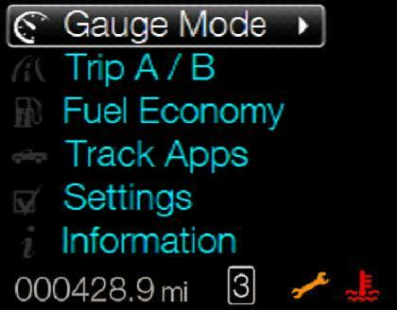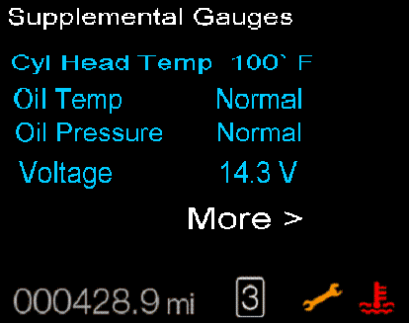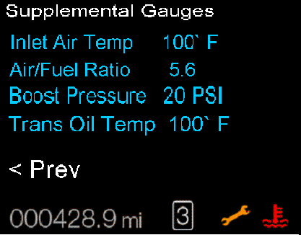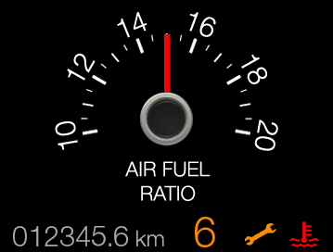

Indicator Color Coordinates
None

HMI-REQ-298739/A-Indicator Characteristics

Description of Gauge | Scale Range | Scale Span | Operating Span
North American | 10 to 20 | 0 – 270 angular degrees | 0 - 270 angular degrees

Audio

None

Switch Control Logic

Not Applicable

PFM-REQ-298740/A-System Accuracy

- Shall indicate the data contained in EngIpcDsplyAfr_Rt_Actl.

Operation: Performance and Functional

Subsystem Algorithm Flowchart / State Diagram

F-REQ-298722/A-Air to Fuel Ratio Numeric Gauge Display Update

F-REQ-298723/A-Air to Fuel Ratio Virtual Gauge Display Pointer Update

HMI-REQ-298724/A-Air to Fuel Ratio Numeric and Virtual Gauge Display

Operation Description (supports algorithm flowchart /state diagram)

F-REQ-298725/A-Powertrain_Cluster_Info_4 Declared Missing
- Gauge pointer shall move to lowest defined chaplet at max rate when Powertrain_Cluster_Info_4 is declared missing as per section 1.4.1

F-REQ-298726/A-Air to Fuel ratio virtual Gauge Needle Waver
- The Air to Fuel ratio virtual Gauge display shall not exhibit needle waver exceeding 1/3 of an angular degree with a steady commanded input.

F-REQ-298727/A-Gauge Pointer Overshoot Recovery Condition
- Pointer overshoot and return to that ratio value contained in EngIpcDsplyAfr_Rt_Actl Signal shall not exceed one angular degree.

F-REQ-298728/A-Air to Fuel Ratio Gauge Display Signal Sampling
- The Air to Fuel Ratio display and virtual Gauge display shall sample the contained in EngIpcDsplyAfr_Rt_Actl Signal at the predefined message's periodic rate.

F-REQ-298729/A-Virtual Gauge Pointer Position Refresh Rate
- The cluster shall update the virtual gauge pointer position at least every 100 msec since the Air to Fuel ratio virtual gauge has a high degree of pointer movement.

F-REQ-298730/A-Gauge Pointer Target Position Calculations
- The cluster shall linear interpolate between input values to calculate the target position to ensure smooth pointer movement between targets.

F-REQ-298731/A-Air to Fuel Ratio Gauge Display Disable Configuration
- The Air to Fuel ratio numeric and virtual gauge display screens shall not be displayed if Air_to_Fuel_Ratio_display_Cfg is set to Disabled (0x0).

FS-REQ-298741/A;1-Function Safety Classification (EMC)

B

NVM-REQ-298742/A-Memory Storage

Parameter Name | Description | Value at  Battery Connect | Value at  Module Wake-up
Air to Fuel Ratio Display | Displays the numerical value of the air to fuel ratio in the engine. | Inactive | Inactive
Air to Fuel Ratio Virtual Gauge display | Use to display virtual Air to Fuel ratio display | Inactive | Inactive
EngIpcDsplyAfr_Rt_Actl Signal | CAN signal sent from the PCM. | 0 (0x0) | 0 (0x0)
Air_to_Fuel_Ratio_display_Cfg | State indicator for feature presence controlled via CAN at EOL at VO plant. Set to Disabled at Cluster Supplier Manufacturing Plant | Use Stored Value | Use Stored Value
Operational_Mode | 4 state indicator for cluster operational mode | Limited | Limited, Normal or Crank

Prove Out

No

Error Handling

Missing Message Strategy
The signals will be declared missing as per the Diagnostics section of this SPSS.

DTCs states and history will be determined as per the Diagnostics section of this SPSS.

Diagnostics

Self Test
None.

Engineering Test Mode
Reference section “Dealer / Engineering Test Mode (ETM)”

Part II Performance

DTC-REQ-298733/A-Supported Diagnostic Trouble Codes (DTCs)

DTC | Description | When Logged
C10000 | Lost Communication with PCM | When Powertrain_Cluster_Info_4 message is missing for >= 5 seconds.

DCR-REQ-298734/A-DID DExx

Block  Num | Block Description | Size (bits) | Byte | Bit | State: Description | "0" | "1" | Default | Comments
PACKETED BLOCKS
$00 | Option Content (B&A) | 1 | * | * | Virtual Gauges | Disabled | Enabled | Disabled
*Byte and bit location to be identified in Part II Specification for this cluster

Reference Specification

- Func. Criticality EC-0048
- Mod. PWR-up / Reset EC-0049
- Low-High Vol. Perform. EC-0058
- Instr. & Gauges (indic. Grad) IS-0015
- Oper. Voltage Perf. IS-0052
- Oper. Voltage Func. IS-0053
- Symbol Usage 01-0238 / 01-0239
- Symbol Leg. 01-0240
- Harmony: Graphics / Font / Ill. 17-0040
- Ergo - Access. 17-0052
- Ergo - Operablility 17-0053
- Control & Display Loc. 17-0060
- Ill. Controls & Disp. 17-0074
- Logic of Op. 17-0120
- Op. Stereotypes 17-0121
- Interpretation 17-0122
- Feedback 17-0124

Revision History
SPSS Module Revision History

Revision Level | Name | Change Description | Date
1.0 | V.Patel | Initial release for CGEA 1.3, based on Air to Fuel Ratio Gauge Display S197 v1.2 STSS dated April 20, 2010. | 7/31/2012
1.1 | Mlenkner | Changed Virtual_Gauge_Cfg to Air_to_Fuel_Ratio_display_Cfg throughout | 12/11/12
1.2 | S. Watkins | CAN signal EngIpcDsplyAfr_Rt_Actl is actually defined as valid up through $FF (25.5). Gauge graphics go to $C8 (20). Values greater than 20 are pegged to 20 ($C9 - $FF). Formerly these values caused dashes to be displayed.  - Section 1.2.2 – Updated Table 1.0 to show max value of 25.5.  - Section 1.3.5.1 – Add action box to clamp EngIpcDsplyAfr_Rt_Actl at 20 for values greater than 20. | 9/12/2013
1.3 | A. Mishra | Initial VSEM RM Dcoument | 2/26/2018

